Project 1

Creating a blog using Kubernetes

1. Create the namespace Called Blog through a Yaml file

1. Frontend Deployment, Service, and Ingress using frontend yaml file which contains:
   1. Deployment of Nginx alpine image:

* 1. Creating a Service and Selecting Cluster IP:

* 1. Creating and Exposing an Ingress Source:

* 1. A black background with white text

     Description automatically generatedApplying the Frontend.yaml file:

1. Creating and Setting Backend Part:
   1. A computer screen with white text

      Description automatically generated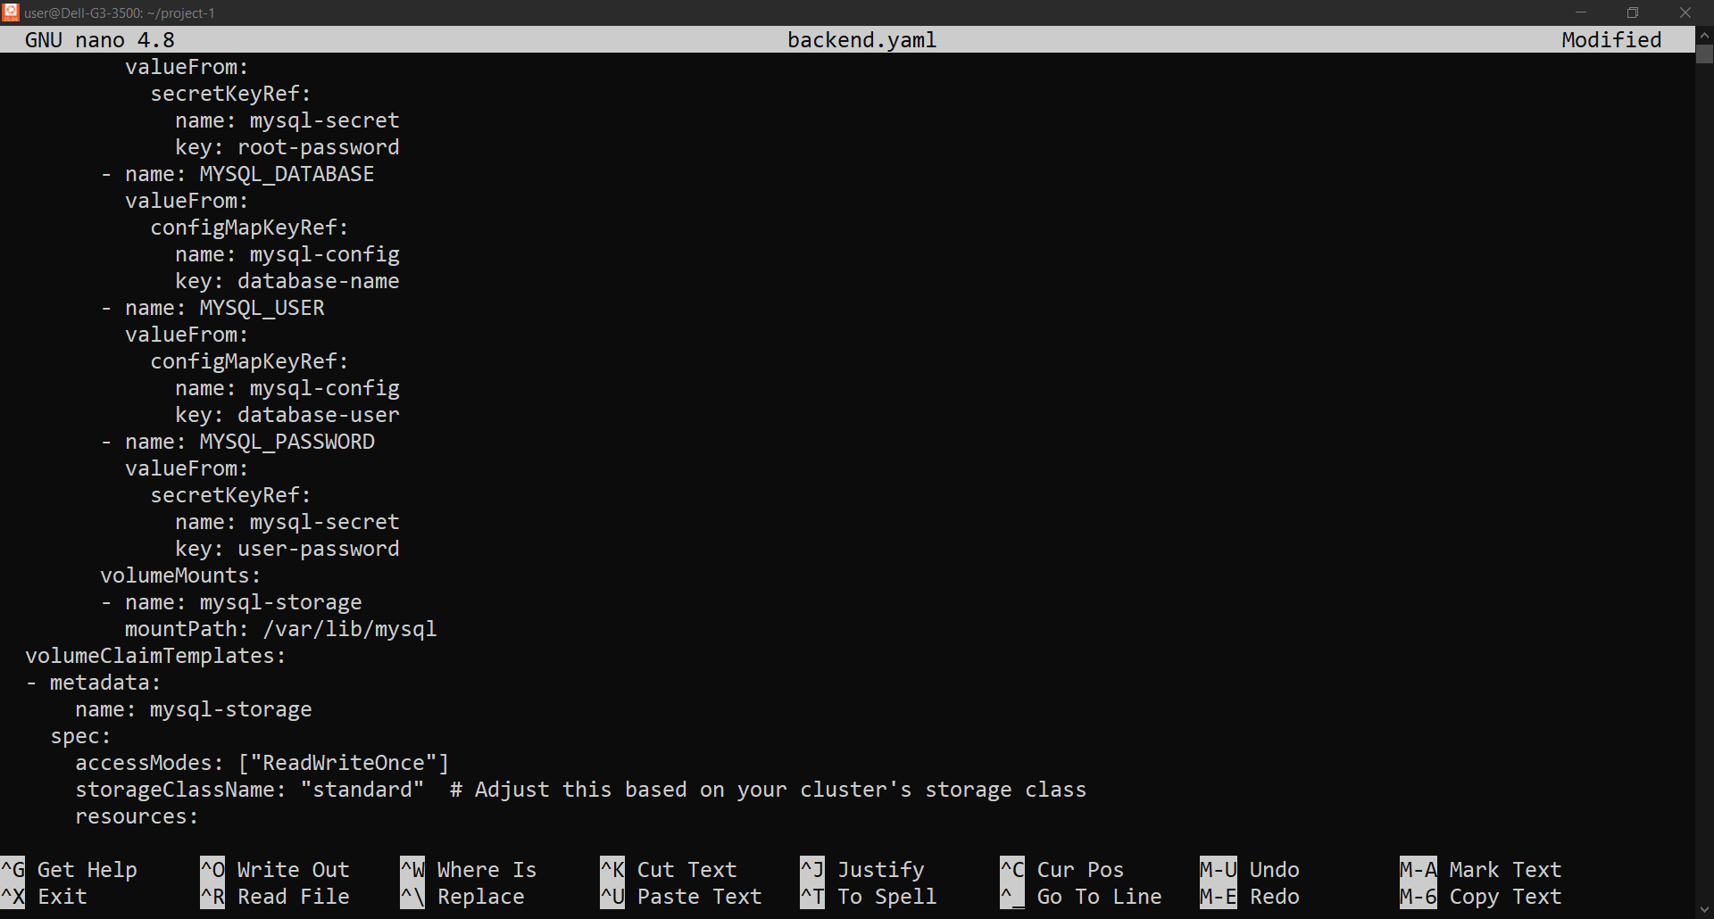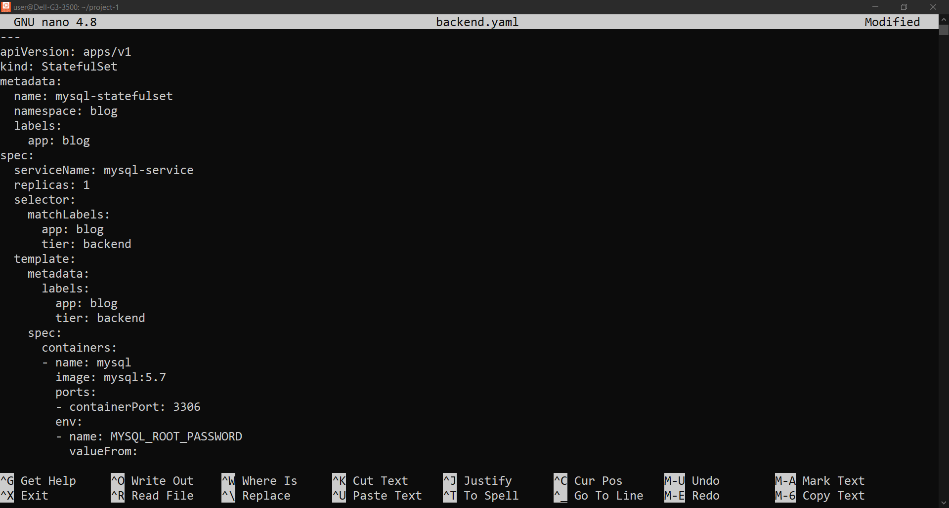Deploying MySQL image and Creating a PVC of 1Gi:

* 1. Exposing the Service used By Backend:

* 1. A black background with white text

     Description automatically generatedApplying Backend yaml file:

1. Creating a Horizontal Pod Autoscaler:
   1. Creating Yaml file Setting min and max replicas and CPU utilization to 50%:

1. A black background with white text

   Description automatically generatedA computer screen shot of a black screen

   Description automatically generatedCreating Config Map and Secret:
2. Project Verification:
   1. A black background with white text

      Description automatically generatedAccess the blog frontend through Browser:

We need to get the ip first then we use it through browser to access the webpage

* 1. 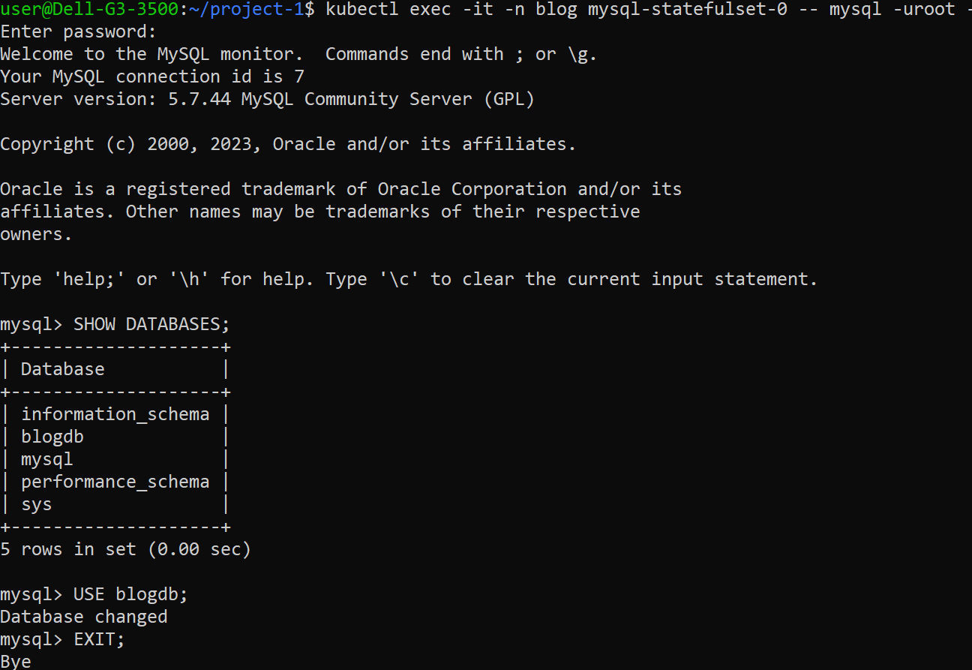A screenshot of a computer

     Description automatically generatedTesting the SQL database:

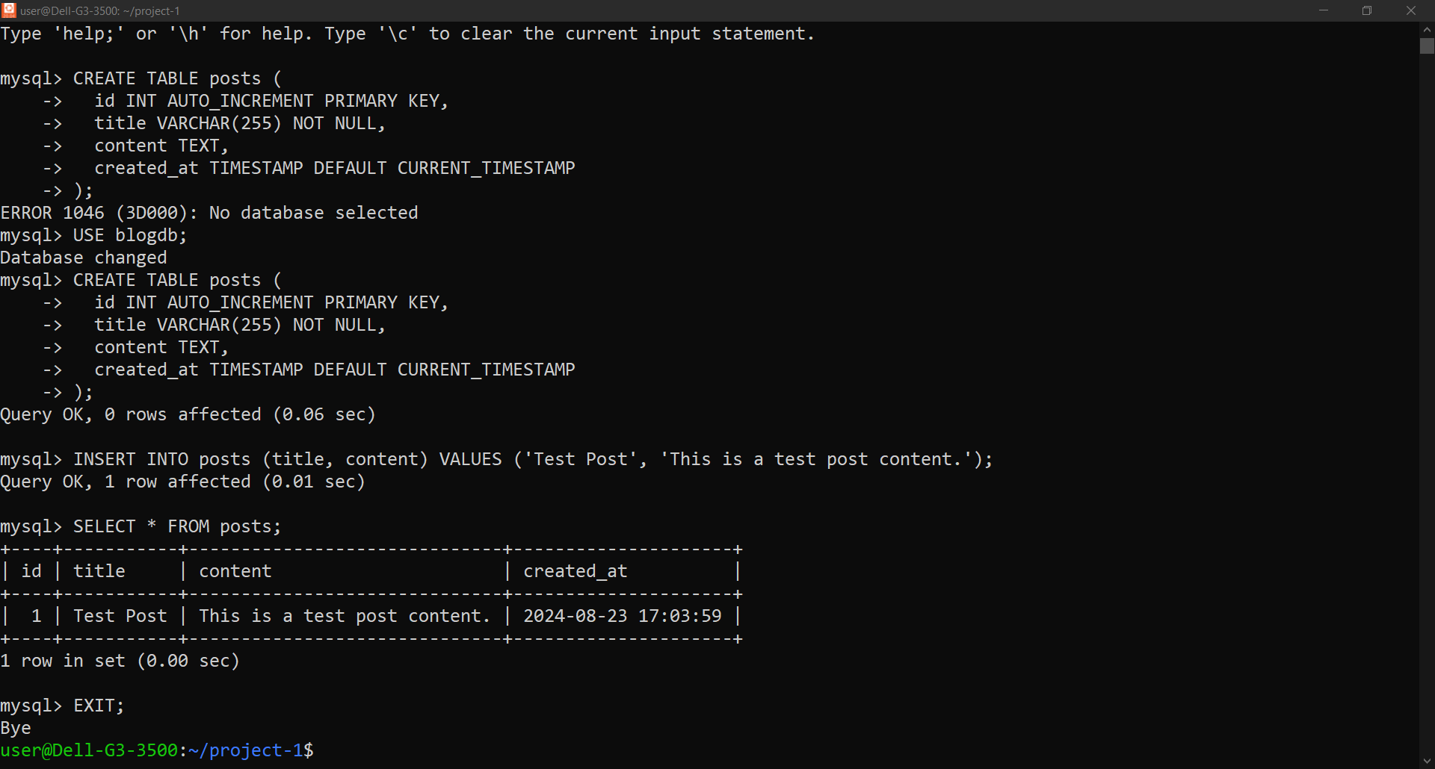

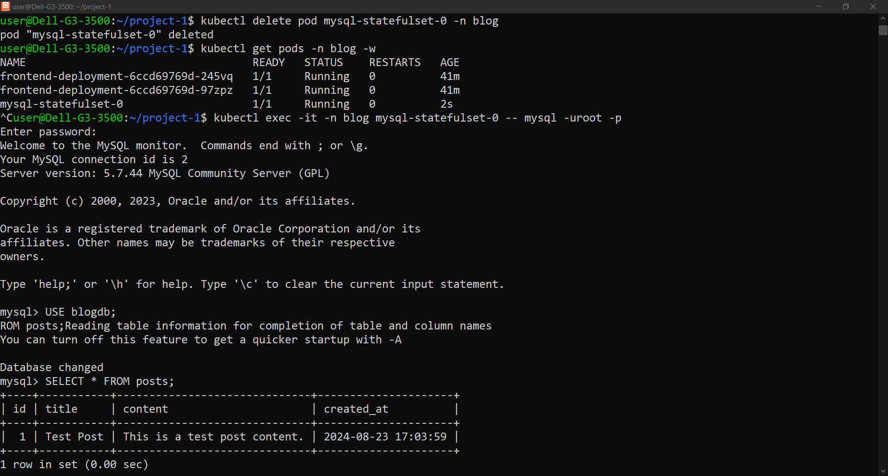We Created a simple table to test if we deleted the pod containing the database and creating it the data will persist:

1. 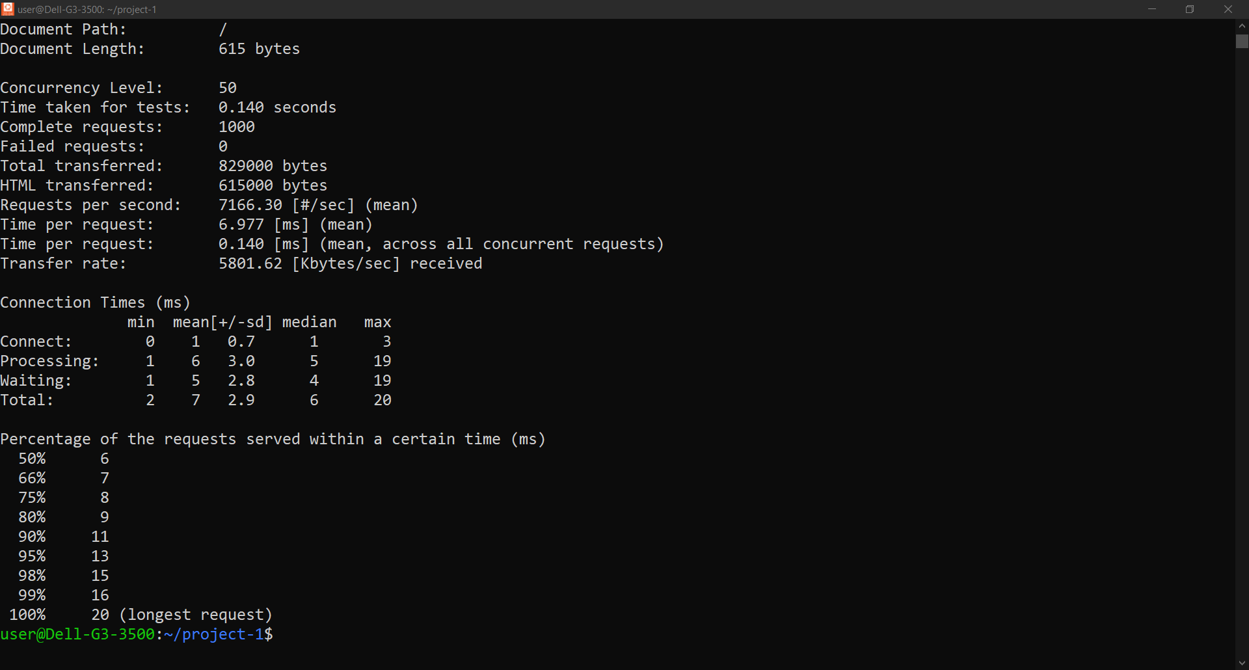Testing HPA:

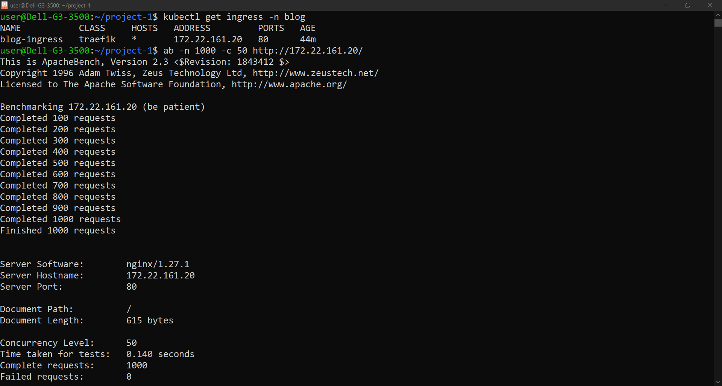

1. A computer screen shot of a black screen

   Description automatically generatedChanging the Image version from alpine to latest to test data persistent and system recovery speed:

